Compiler Construction
Enumeration Types in Triangle

Rio Velarde
Velar102@mail.chapman.edu

Abstract: Enumeration types are very helpful types that allow you to create entities that have a variety of different states. The concepts of states are inherently present in many tasks and although they can essentially be coded without enumeration types in the program, the presence of enumeration types makes this much easier and streamlines the changing of states in an easy-to-understand way. States can represent various statuses of characters in video games, the currently selected option in a menu, or even just the current value of an integer variable. Enumeration types can be utilized for unlimited numbers of tasks and I believe the addition of them to Triangle greatly improves the language and would help ease the programming of most projects in it.

- Introduction
For my project, I chose to extend the Triangle language with an enumeration type. I am familiar with enumeration types from coding game projects in the past, so this seemed like a promising project to work on. I implemented the needed changes for the inclusion of enumeration types into triangle in stages throughout the semester. Those stages were modifications of methods needed for Syntactical Analysis, Contextual Analysis, Run-Time Organization, Code Generation, and finally the Interpreter/Disassembler. The project was completed successfully with the main advantages for my enumeration type implementation being the ability to create a type with various states that allows for creation of a variable of that type which can switch between all of the specified types. The states and variables of these enumeration types are then represented by integers within the TAM and thus operations involving them can be easily and quickly carried out. I also allowed for the assignment of integers directly to the enumeration variables as well as integer variables. This will be discussed in more detail throughout the paper.
- Triangle Language Changes
2.1 Syntax
As enumeration types are, of course, types, the main enumeration extension is added to the Triangle specification in the Type-Denoter section. For this, an EnumTypeDenoter type was added there:
Type Denoter := enum { EnumConstDeclarationList }
Of course, as this uses a new List titled an EnumConstDeclarationList, that needed to be added as well. As it is very similar to an ArrayAggregate, I chose to add this to the Expressions specification section alongside ArrayAggregate:
EnumConstDeclarationList := EnumConstDeclaration
| EnumConstDeclaration, EnumConstDeclarationList
This is a recursive format that is actually modeled after the ArrayAggregate format. Finally, EnumConstDeclaration, which will represent the declarations of the actual states in the enumeration type, is included in the Declarations specification as well:
EnumConstDeclaration := Identifier
Although it is merely represented by an identifier within the specifications, we will see later during the AST creation that it actually has more to it than simply being an identifier.
2.2 Semantics
- EnumConstDeclarationLists denote all the states that will belong to the specific enumeration type being created.
- An EnumConstDecleration is used to represent each one of the states of the enumeration type. They are all to be included within the EnumConstDeclarationList.
- EnumConstDeclarations are recommended to be typed in all caps, as they are constants. However, this is not enforced and they may be typed other ways.
- EnumConstDeclarations cannot have the same names. Only one declaration is allowed to have each chosen name, even throughout different enumeration types. This is forced to ensure proper type checking.
- The first state in the EnumConstDeclaration list will be assigned the integer representation of 1. The next will be assigned a 2 and so on. These values can be used for subsequent assign commands.
2.3 Examples
The following is an example of how an EnumTypeDenoter would look in code:
var Day : enum { SUNDAY, MONDAY, TUESDAY, WEDNESDAY, THURSDAY, FRIDAY, SATURDAY }
And here is how it is implemented:
Day := MONDAY;
Day := WEDNESDAY;
if Day = MONDAY then putin(3) else putint(5)
- Triangle Implementation Changes
3.1 Parser / Abstract Syntax Trees
For this program, I had to create five abstract syntax trees: EnumTypeDenoter, EnumConstDeclarList (Abstract), MultiEnumConstDeclarList, SingleEnumConstDeclarList, and EnumConstDeclaration. The EnumConstDeclaration AST is used to represent each state in the enumeration type as an object. There are three different things contained in this AST class:
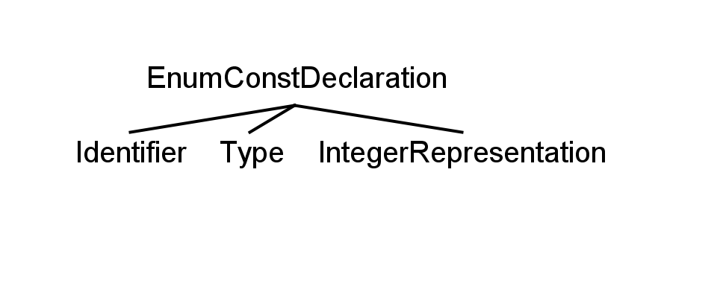
An Identifier is simply what the state will be referred to as. In the previous example, this would be MONDAY, TUESDAY, etc. The type specifies which enumeration type each enumeration state belongs to. This is used to ensure proper type checking between different enumeration types. The IntegerRepresenttation (IR) is simply an integer that denotes which number each state will be represented by. The details of assigning the type an IntegerRepresentation will be is discussed in contextual analysis.
Next, there are the EnumConstDeclarationList ASTs. Since each enumeration type will have an unknown number of states, it is necessary to ensure that any amount of states will be accepted. This is done by having every MultiEnumConstDeclarationList contain not only the EnumTypeDenoter to represent each specific state, but also another instance of the abstract EnumConstDeclarationList class. This could be either Single (containing simply an EnumConstDeclaration) if there is only one left or another Multi (having both the constant delcaration and another List) if there are still more states to come. This allows the specified number of states to be properly parsed and utilized. Here is a diagram to illustrate the concept:
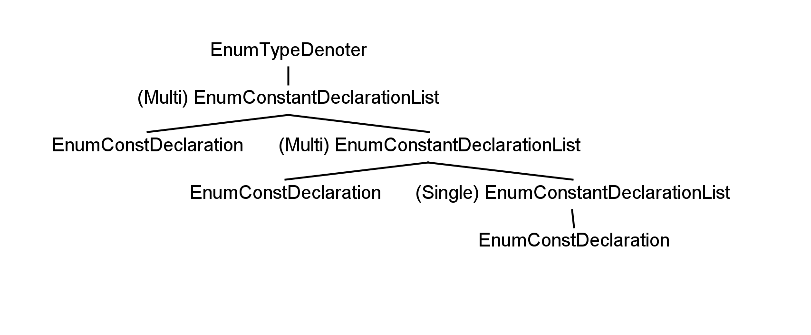
Finally, there is the EnumTypeDenoter AST itself. Only two things need to be included in this class. There is the EnumConstDeclaration list that contains all the states for the specific enumeration type and an ElementCount that will keep track of how many states the enumeration type has.
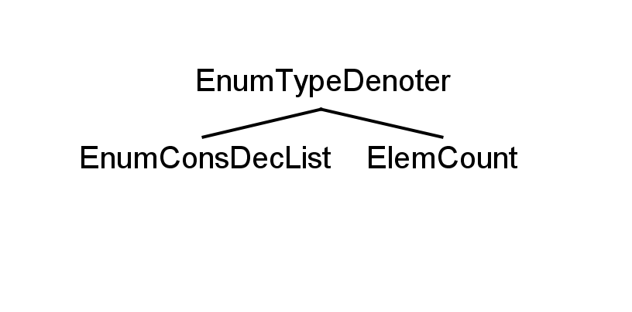
When an instance of enumTypeDenoter is created, the parsed list is passed to it to initialize the states and the ElemCount is simply set to 0 for now. It will be incremente later during contextual analysis. A switch case was added to parseTypeDenoter for the enumeration type denoter to be parsed. As the type denoter statement simply contains the enumeration constant declaration list, all that was needed was to accept the ENUM token, parse the declaration list and the opening and closing brackets, and then finally create the enumTypeDenoter object.
The parsing of the declaration list is handled recursively. It parses the first EnumConstDeclaration then detects if the current token is a comma. If it is, the parser knows there is more and calls parseEnumConstDeclarationList from within itself. A new instance of MultiEnumConstDeclarList is then created, with the previously parsed EnumConstDeclaration and the result of the Multi parse call passed to it. This repeats until there are no more commas detected. One this occurs, it knows it has parsed everything and creates a new SingleEnumConstDeclarList is created passing only the last parsed ConstDeclaration to it. This method can be seen in the appendix (Item A.1). It was higly modeled after the parseArrayAggregate method that already existed in Triangle.
Finally, there is the parseEnumConstDeclaration method. All this method does is simply parse the Identifier and create a new EnumConstDeclaration object with the result of the Identifier parsing sent to it. To conclude this section, it is worth noting that the Token class also had to be modified slightly to add Enum as a reserved word.
3.2 Contextual Analyzer
The first step in contextual analysis was to add the enumeration constant declaration identifiers into the IDTable so that they could be referenced later when being assigned to an enumeration variable. As the checker implements the visitor method, this was done by having a visit to the type denoter call the visit method of its list, which in turn calls the visitor method of each enumeration constant declaration within it. It is there that the Identifiers for each state are added to the ID Table one by one as they are each visited.
The next step of contextual analysis was to ensure proper type checking. This means that assignments from states of one enumeration type into variables of a different enumeration type must be stopped. This is where the type field is utilized. In order to set the type of all the EnumConstDeclaration’s properly, when the visit method for the list is called, the enumTypeDenoter actually passes the enumTypeDenoter itself as an object to the list. The list then continues the chain by passing on the object down to each EnumConstDeclaration. Once there, the object is typecast into a type denoter and assigned to the type field for that state.
A case is then added in visitSimpleVName where the constDeclaration’s type is set as the type of the variable when it is found the variable is an instance of an EnumConstDeclaration. The already existant code in visitAssignCommand then takes care of the rest of the type checking and ensures all states being assigned to the enumeration variable are of the same type.
Since the object is already being passed, it is also here in the constant declaration visit method that I increment the enumTypeDenoter elemCount by one every time a constant declaration is visited. I also set the integer representations of the enum constant declarations equal to the current elemCount in the EnumTypeDenoter object, which ensures they are given proper incremental integer assignments for them to be represented as.
Although the visitAssignCommand takes care of type checking the state identifiers being assigned to the enumeration variables, I wanted to make enumerations more useful by also allowing the assignment of integers and integer variables to enumeration variables. For example, the following assignments are all permitted after the given declarations:
var Day : enum { SUNDAY, MONDAY, TUESDAY }
var num : Integer
Day := 2
num := 3
Day := num

To accomplish this, the visitAssignComamnd had to be edited to also allow for the assignments of the two different types into the different type of the enumeration variable. To accomplish this, I allowed all integer expressions on the RHS to pass without error aside from simple integers that were out of range of the enumeration type. This was checked with an If statement after getting the ElemCount from the TypeDenoter through some typecasting of the AST currently being visited. Integer variables are checked for range bounds within the TAM later, since their values are not known now. So, they are all allowed to pass through contextual analysis for now if they are being assigned to the enumeration variable.

The allowing of integers and integer variables to be assigned to enumeration variables seemed sensible as you would want to increment states by a certain amount or set the state of something equal to what a variable is currently at in order to make full use of the potential that enumerations provide. The visitAssignCommand method now has to check for if an enumeration type is on the LHS and then apply the special rules.

3.3 Run-Time Organization / Code Generation

For Run-Time Organization, enumeration constant declarations had to be set to be treated as integers in the Encoder. This was easily done as I already set the proper integer for each enum constant declaration in their respective integer representation fields during contextual analysis. The following line of code sets the entity as having Machine.IntegerSize and the proper integer value:

ast.entity = new KnownValue(Machine.integerSize, ast.IR);

I also had to set the enumeration type denoter size as equal to Machine.IntegerSize. This is because an enumeration variable only takes up the space of one state (which is an integer) at a time. Only one state is active at any given time. This is contrary to arrays which take up the space of every item within.
For the visitAssignCommand in the Encoder, I implemented a special case where if the LHS was an enumeration variable then after the RHS is evaluated, the value is checked to see if it is within the enumeration type range before the value is assigned to the LHS. I did this check with an extension to the TAM in the form of a new op code. Although the call to check the variable is in the Encoder, the actual check is not done until the program is ran during interpretation.

All the visit methods also manage the proper creation of new frames that are needed and result in the generation of the correct stack commands. Here are the desired code templates of how the Interpreter should manipulate the stack. These have been verified with the disassembler:

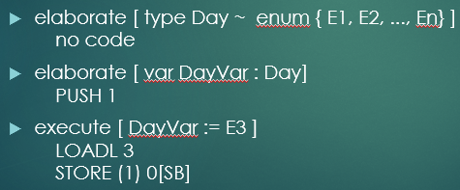
3.4 Interpretation

For the interpreter, I had to add a new op type that allowed me to call a check command to see if integer variables that are being assigned to enumeration variables are within the range of states that the enumeration type contains. The call for this is done in the encoder’s visitAssignCommand between the visitation of E and the call to the emitStore method:

if (vType instanceof EnumTypeDenoter) {
EnumTypeDenoter enumType = (EnumTypeDenoter) vType;
emit(Machine.CHECKop, 0, 0, enumType.elemCount); }

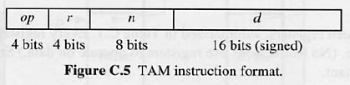
As you can see, I added the new CHECKop constant inside the Machine class to represent this new command. The TAM instruction format allows for three variables to be passed: r, n, and d. I sent 0 for both r and n then used d for the value needed. d is simply the amount of elements in the enumeration type the variable is being checked for compatibility with.

The CHECKop was then implemented in the interpreter to compare the elemcount value with the variable value stored in the stack top of the frame:

case Machine.CHECKop:
int dataValue = data[ST-1];
if (dataValue < 1 || dataValue > d) {
status = failedEnumRange; }
CP = CP + 1;
break;

failedEnumRange is a new fail state that displays an error message indicating the variable was out of range. Here are the lines of code representing the case where it is reached:

case failedEnumRange:
System.out.println("Error: Enumeration value assigned is out of range!");

This covers all the interpreter changes.

3.5 Disassembler

For the disassembler, I simply had to add the new switch case for the check op that output the proper status message. The full stack command from the disassembler can be seen in the apendix with comments explaining everything that is happening (Item A.2).

- Conclusion

Enumeration types have been fully implemented in all phases within my Triangle compiler. While they can be used and are allowed some freedom with the assignment of integers and integer variables to the enumeration variables, there are still more advanced features they could be enhanced with that are already implemented in other languages, such as enumeration methods in Java. These allow you to have methods that return different values depending on which state an enumeration variable is currently in. For example, an enumeration type listing all the planets in the solar system could have a getMass() method that returns the mass of the planet that the variable is currently set to the state of. This could be implemented in Triangle with a lot more work and copying from some of the routine functionality already in Triangle. Although my implementation of enumeration types is not as extensive as that, it offers the main core function of enumeration types to be utilized in Triangle. It was a difficult task to modify the Triangle compiler to allow for enumeration types, but I now feel I have a good understanding of how the compiler works in most stages and areas of code.
References
1. Watt, David A., Brown, Deryck F. Programming Language Processors In Java. Pearson Education Limited, 2000.
2. Enum Types. 1995, 2015 Oracle.
https://docs.oracle.com/javase/tutorial/java/javaOO/enum.html
Appendix
Item A.1

EnumConstDeclarList parseEnumConstDeclarList() throws SyntaxError {
EnumConstDeclarList listAST = null;

SourcePosition listPos = new SourcePosition();
start(listPos);

EnumConstDeclaration ecdAST = parseEnumConstDeclaration();
if (currentToken.kind == Token.COMMA) {
acceptIt();
EnumConstDeclarList ecdlAST = parseEnumConstDeclarList();
finish(listPos);
listAST = new MultiEnumConstDeclarList(ecdAST, ecdlAST, listPos);
} else {
finish(listPos);
listAST = new SingleEnumConstDeclarList(ecdAST, listPos);
}
return listAST;
}

Item A.2

********** TAM Disassembler (Sun Version 2.1) **********
- 0: PUSH 1 // Pushes one space on the stack to elaborate the enum var.
- 1: PUSH 1 // Pushes one space on the stack for the integer variable.
- 2: LOADL 3 // Loads the literal 3.
- 3: STORE (1) 1[SB] // Stores the 3 into the integer variable.
- 4: LOAD (1) 1[SB] // Loads the 3 from the integer variable for the enum assignment.
- 5: CHECK ENUM RANGE // Checks to see if 3 is within the enumeration type’s range.
- 6: STORE (1) 0[SB] // If it is, this value is now set for the enum variable.

